**Ideation Phase**

**Define the Problem Statements**

|  |  |
| --- | --- |
| Date | 27 September 2022 |
| Team ID | PNT2022TMID51170 |
| Project Name | Project - Inventory Management System for Retailers |
| Maximum Marks | 2 Marks |

**Customer Problem Statement Template:**

Create a problem statement to understand your customer's point of view. The Customer Problem Statement template helps you focus on what matters to create experiences people will love.

A well-articulated customer problem statement allows you and your team to find the ideal solution for the challenges your customers face. Throughout the process, you’ll also be able to empathize with your customers, which helps you better understand how they perceive your product or service.

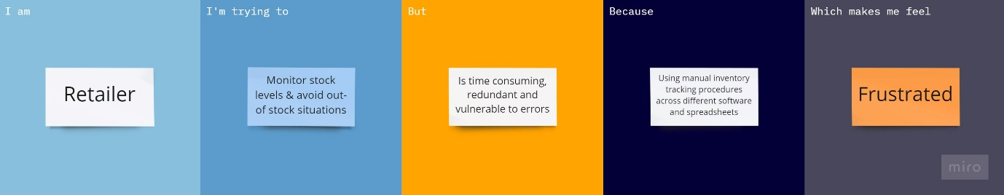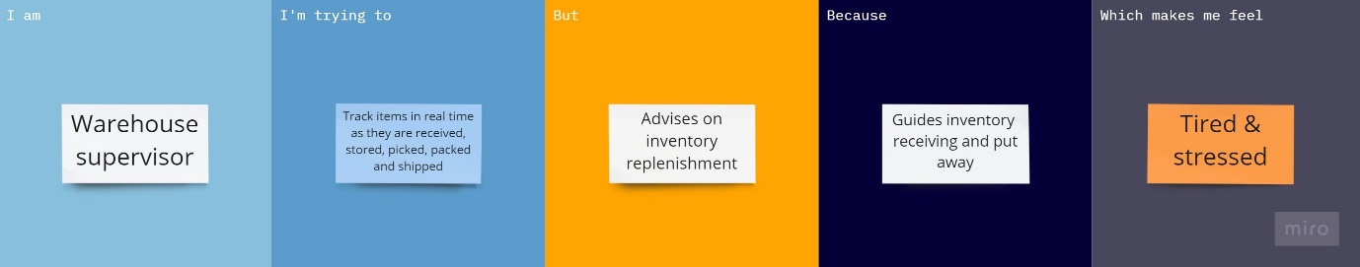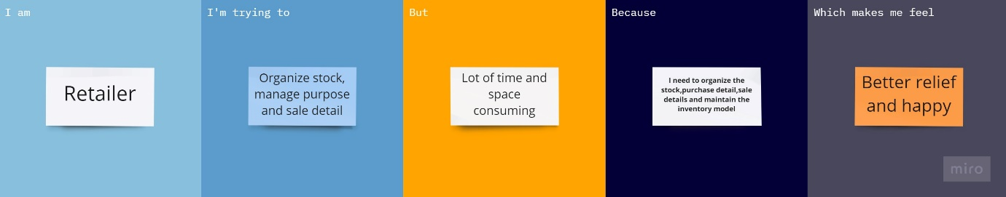

**Example:**

|  |  |  |  |  |  |
| --- | --- | --- | --- | --- | --- |
| **Problem Statement (PS)** | **I am (Customer)** | **I’m trying to** | **But** | **Because** | **Which makes me feel** |
| PS-1 | Retailer | Organize stock, manage purpose and sale detail | Lot of time and space consuming | **I need to organize the stock, purchase detail, sale details and maintain the inventory model** | Better relief and happy |
| PS-2 | Retailer | Monitor stock levels & avoid out of stock situations | Is time consuming, redundant and vulnerable to errors | Using manual inventory tracking procedures across different software and spreadsheets | Frustrated |
| PS-3 | Warehouse supervisor | Track items in real time as they are received, stored, picked, packed and shipped | Advises on inventory replenishment | Guides inventory receiving and put away | Tired & stressed |

Reference: <https://miro.com/app/board/uXjVPSojNw4=/?share_link_id=341739646852>